ASSIGNMENT-2

**BBC NEWS-API**

**Objective:**

To create a web application which makes asynchronous calls to fetch data from BBC News API and display in a categorical way.

**Features of the application:**

This application has a login and signup pages for the users to register their profiles and access their home pages. Home page is where we display the BBC News categorical content with search option to find the relevant content of user’s interest.

**Steps of Execution:**

The development process starts with designing the login page which authenticates the users using their first, last names, email and password credentials.

For new users, signup option is provided which takes them to registration page wherein they must fill up required details to register their profile. Once registered, they can access their home page for their favorite news feeds.

The news was retrieved on the keyword of **“RUSSIA”**

**Screenshots of web-app:**

Signup page:

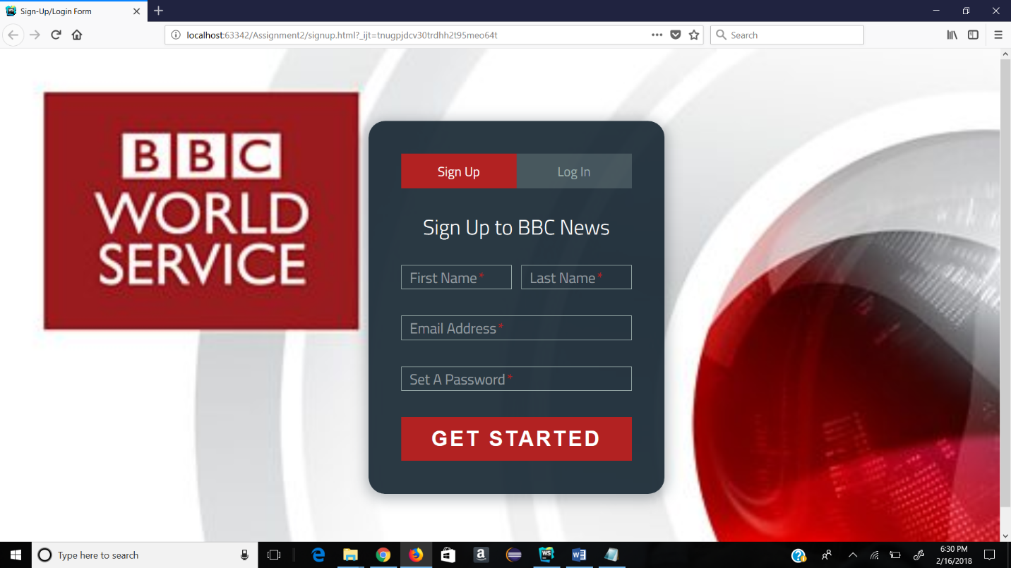

Signup with details:

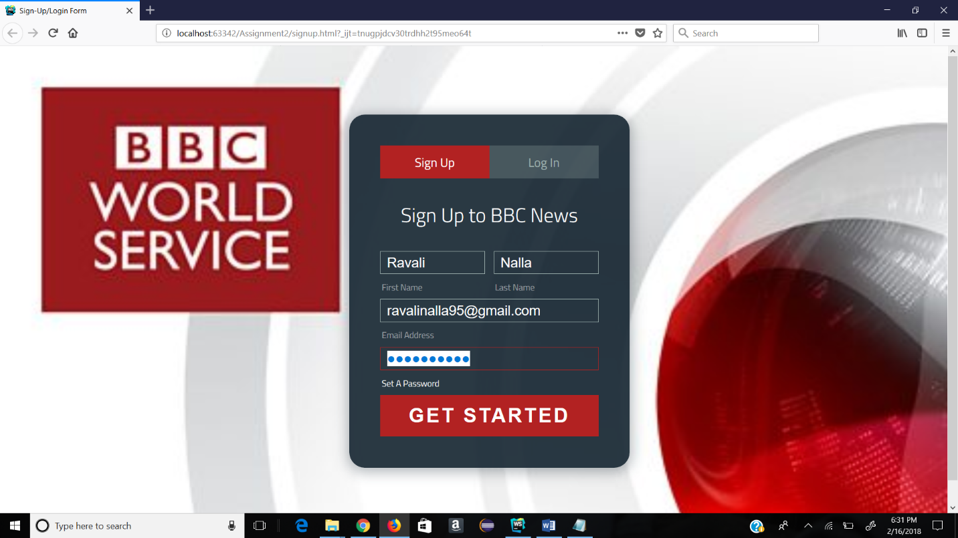

Login page:

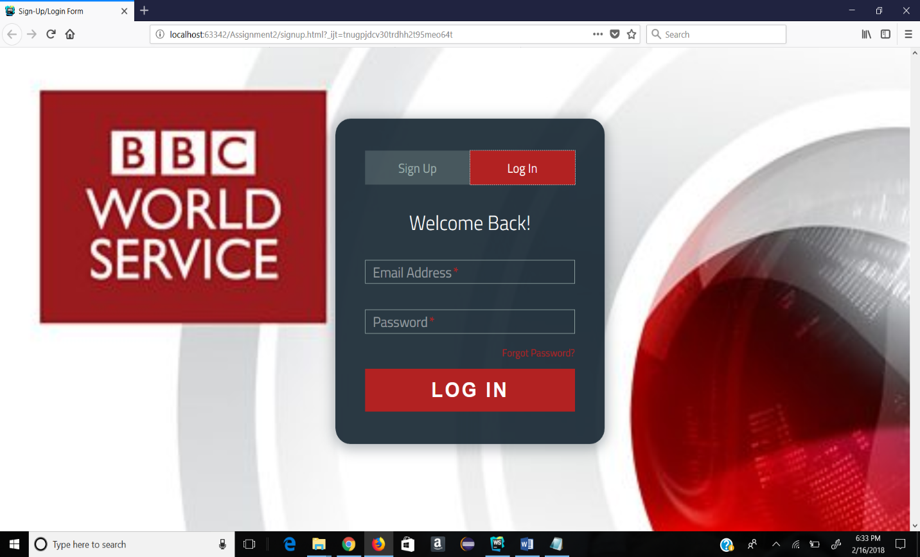

Login with details:

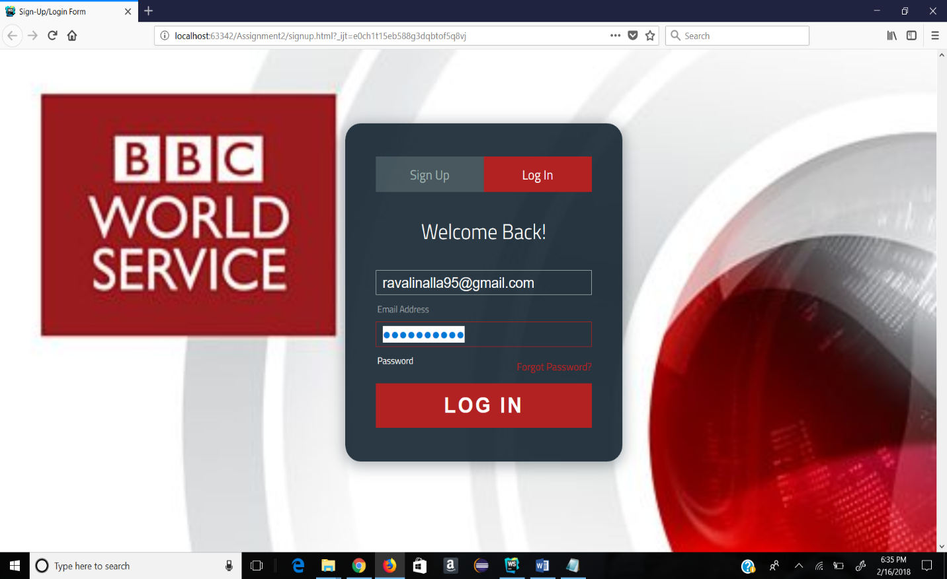

After clicking either “login” or “Get started” button, the home page is displayed.

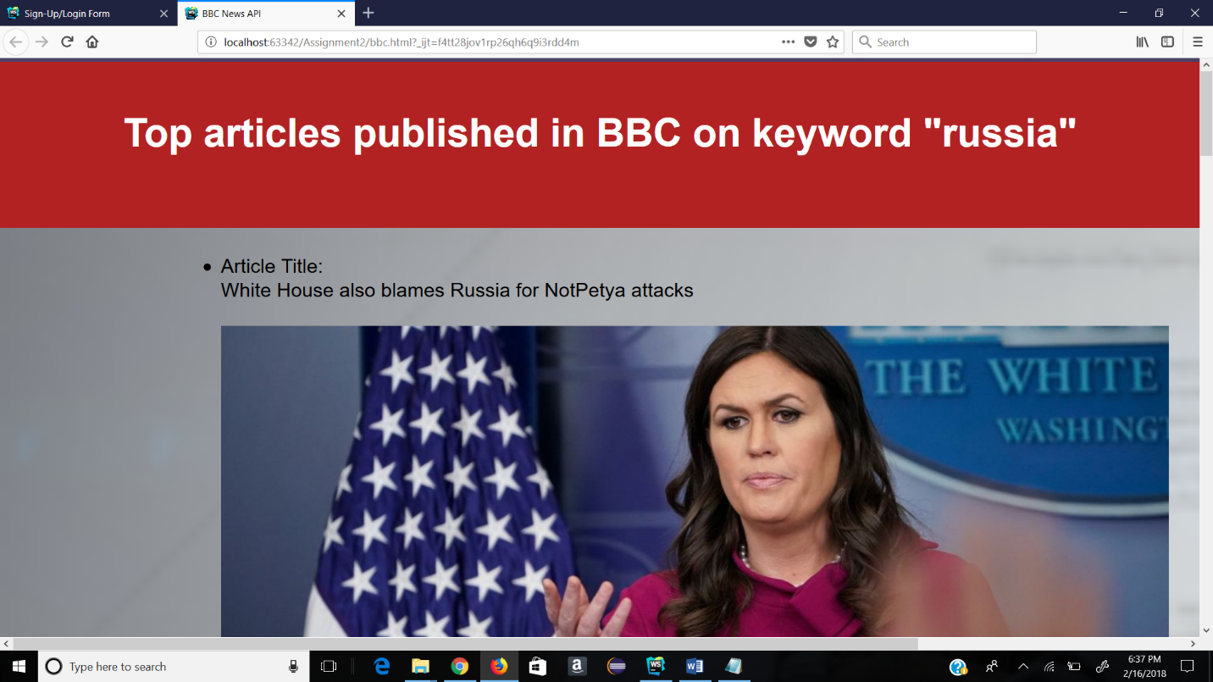

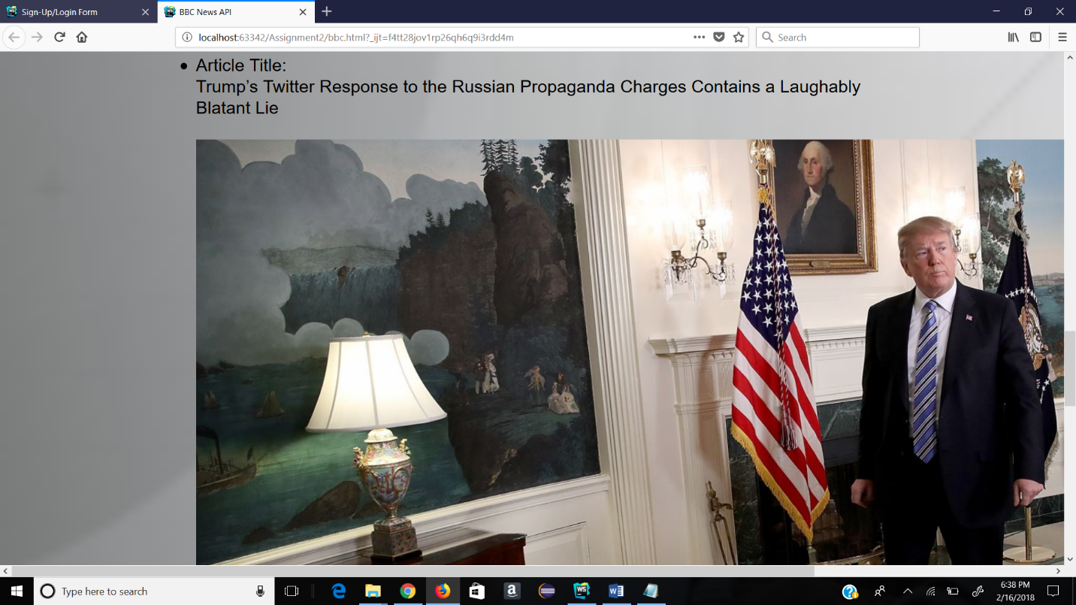

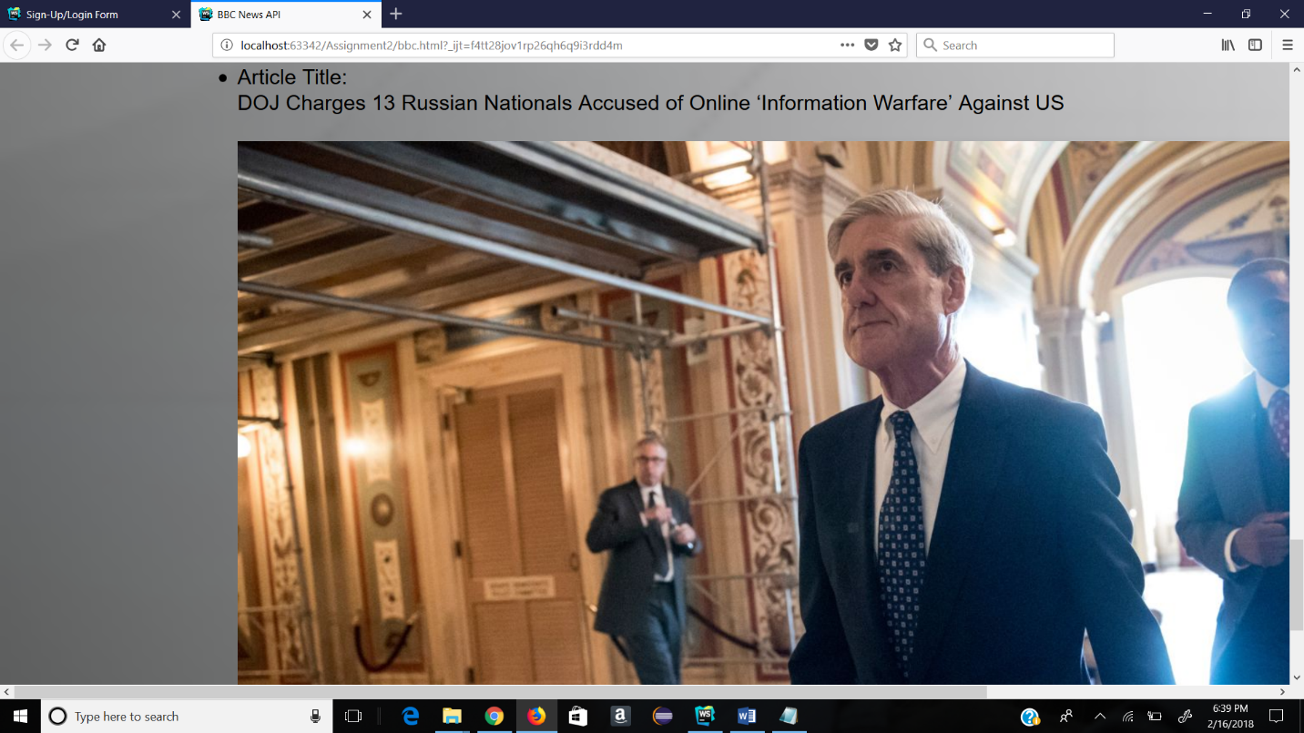

On clicking the images, the related articles are displayed in new tab.

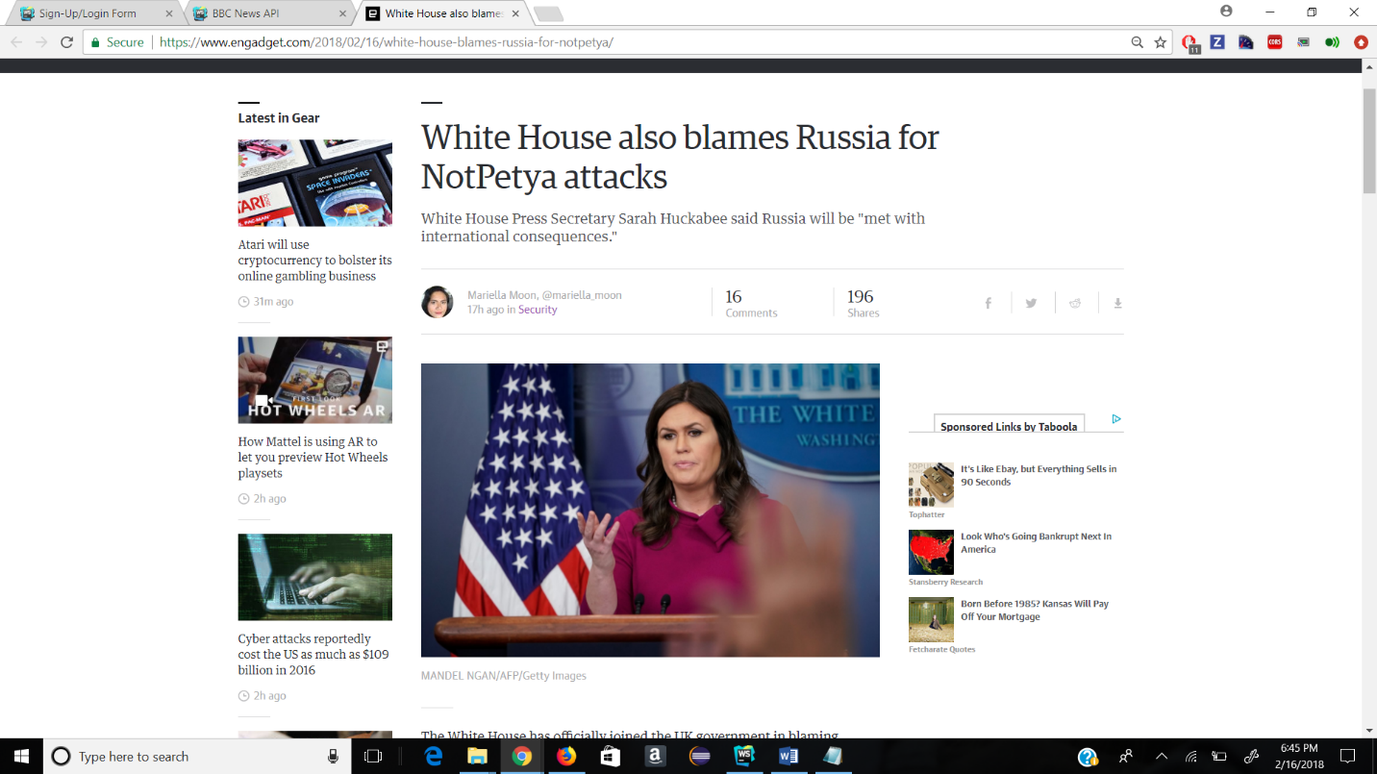

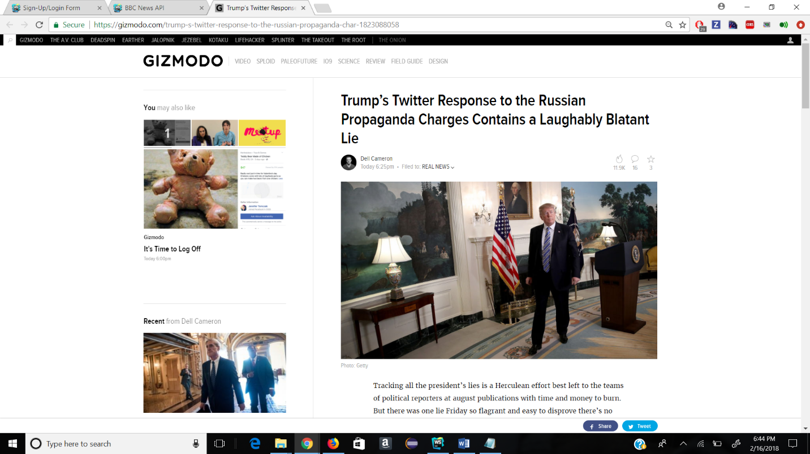



**Code snippets:**

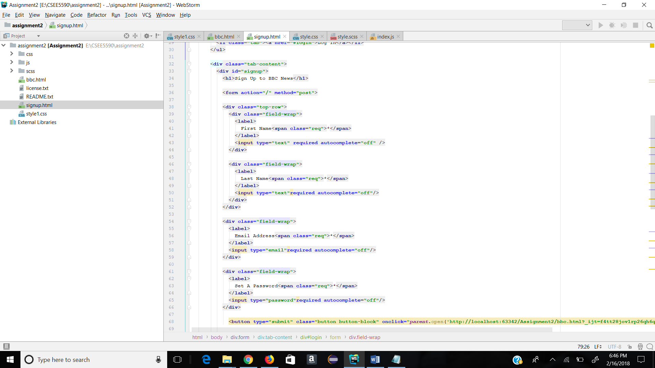

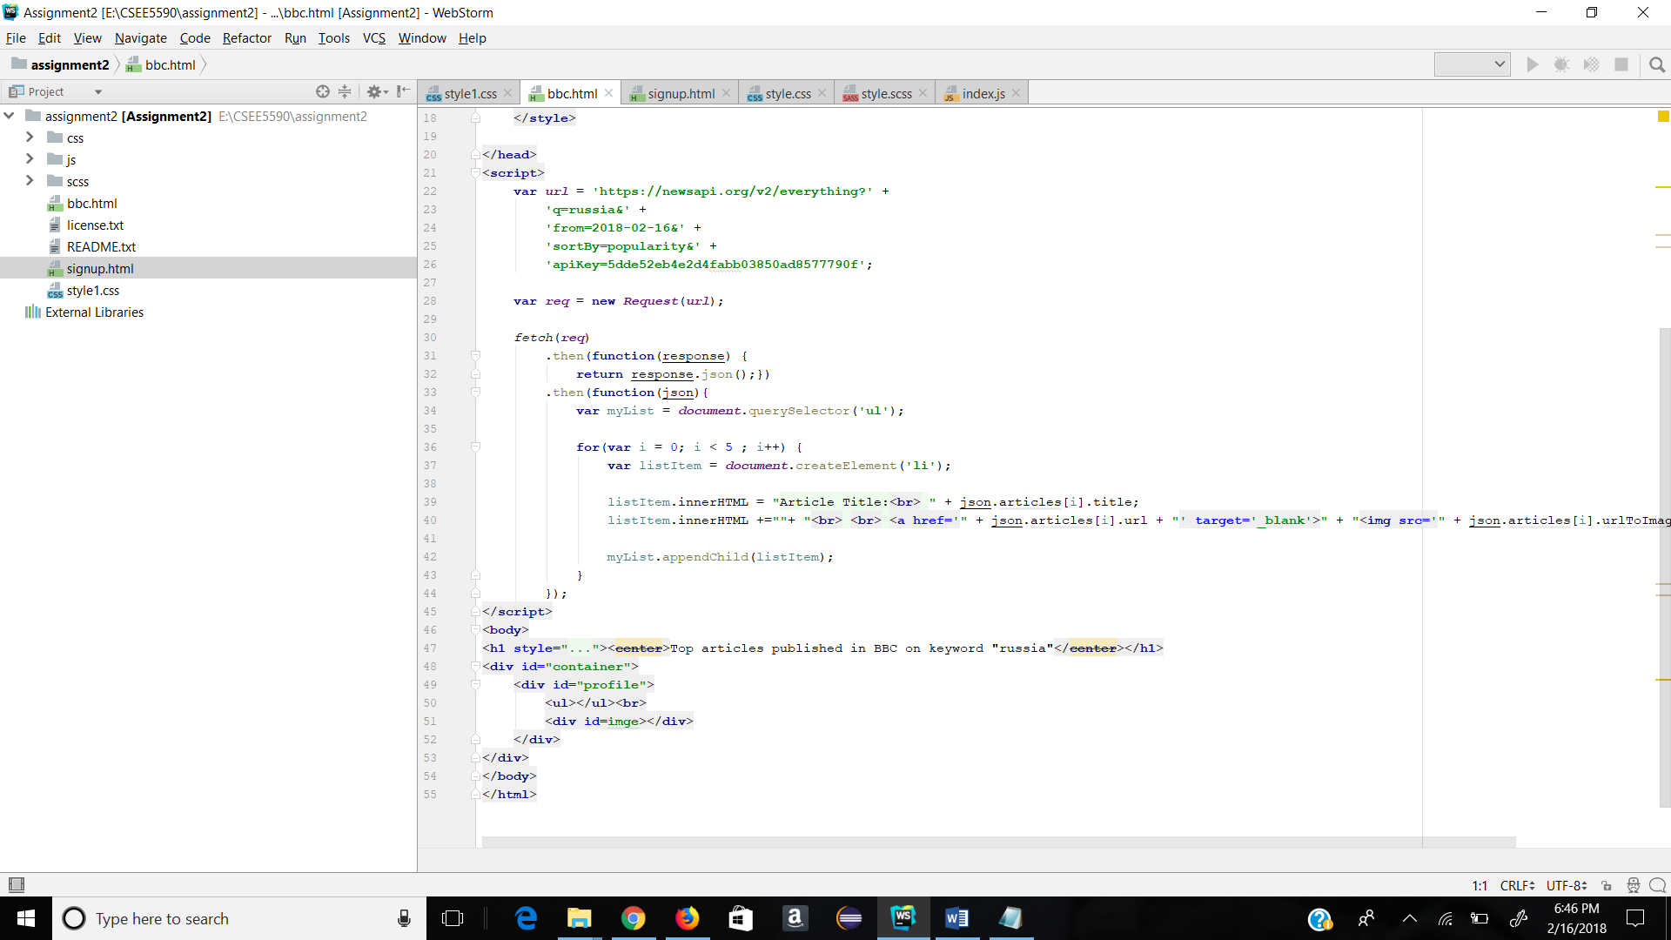

**Tic-Tac-Toe GAME with ANGULAR JS**

**Objective:**

To develop a TicTacToe game with angular JS.

**Tic-tac-toe Game:**

**Tic-tac-toe** is a [paper-and-pencil game](https://en.wikipedia.org/wiki/Paper-and-pencil_game) for two players, X and O, who take turns marking the spaces in a mXm grid. The player who place their marks in a horizontal, vertical, or diagonal row wins the game.

**Features of Tic-tac-toe Game:**

* An Empty board of size 3x3,4x4,5x5,6x6
* User has an option to select the board size(3x3,4x4,5x5,6x6)
* Contains two players (player1 and player2)
* Recursive method to fill the blocks with either X or O until any of the players wins the game
* Displays the score of each player

**Steps of Execution:**

**1.**This is the web page with tic-tac-toe game where user can select their own grid size and can reset it.

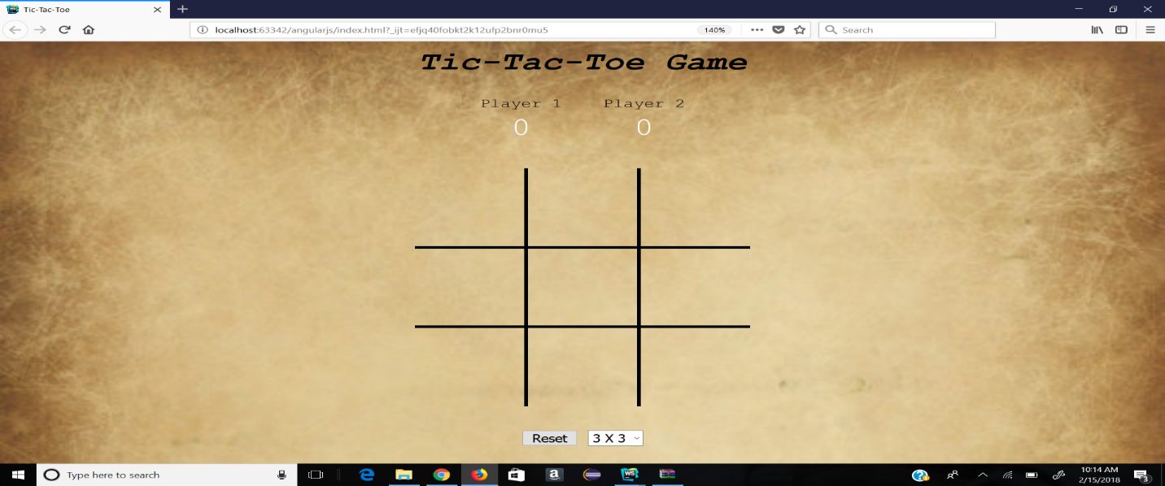

**2.**Two players X and O will be playing this game. The players need to mark their own markings in the grid. To succeed, their marks should be either horizontally or vertically or diagonally.

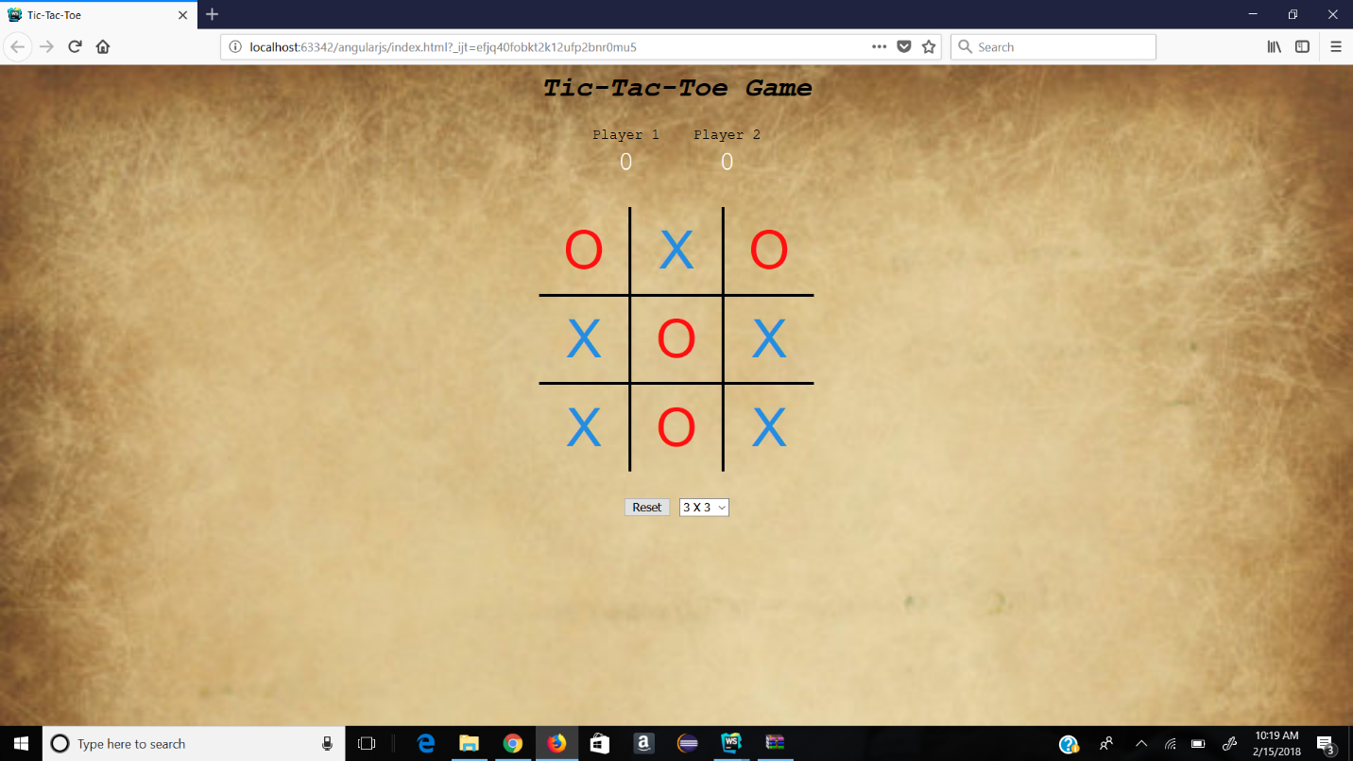

**3.**This screenshot shows the grid size of 4X4.

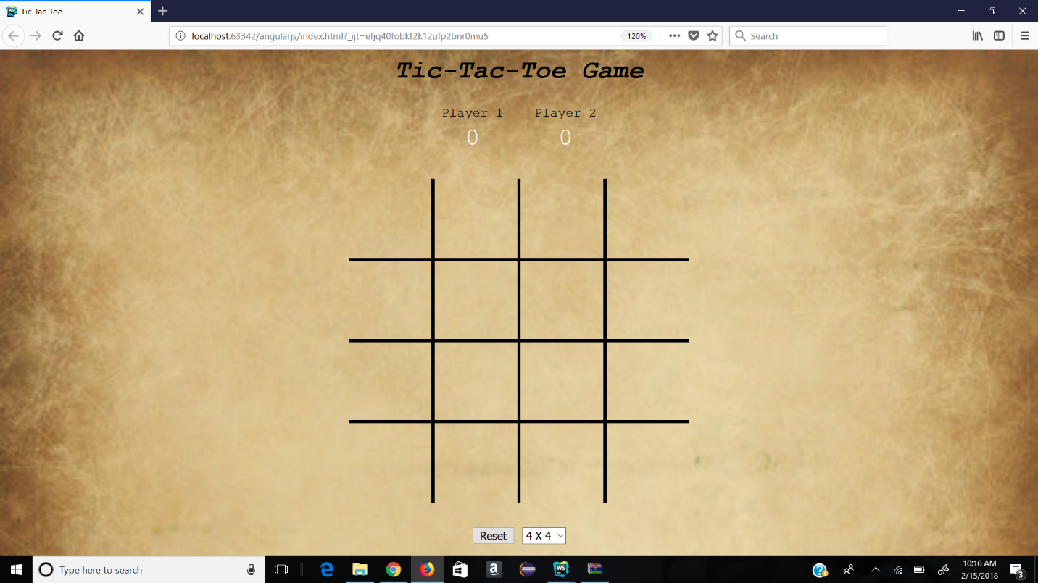

**4.**This screenshot shows the grid size of 5X5.

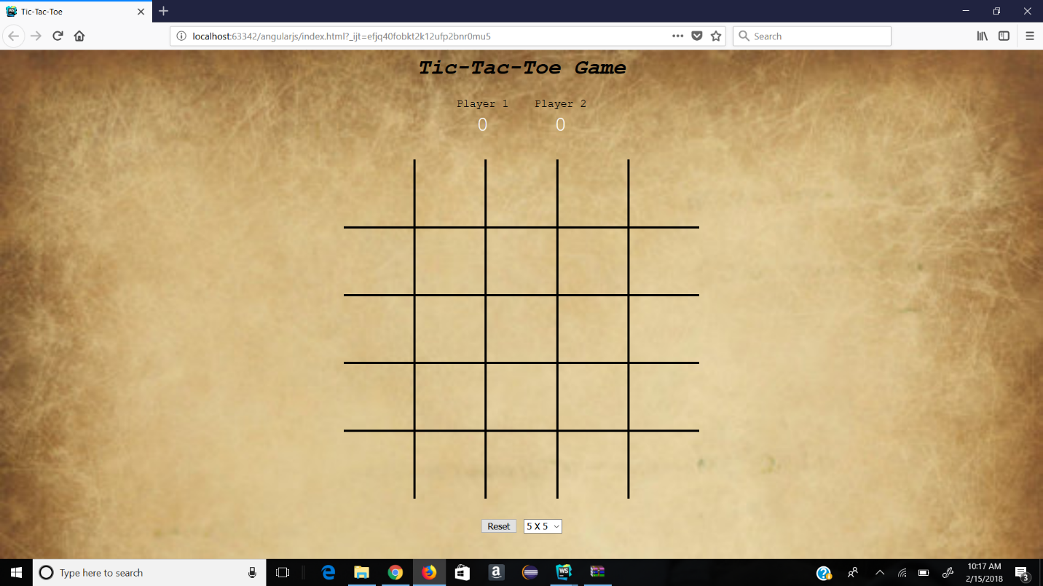

**5.**Game play on 4X4 grid

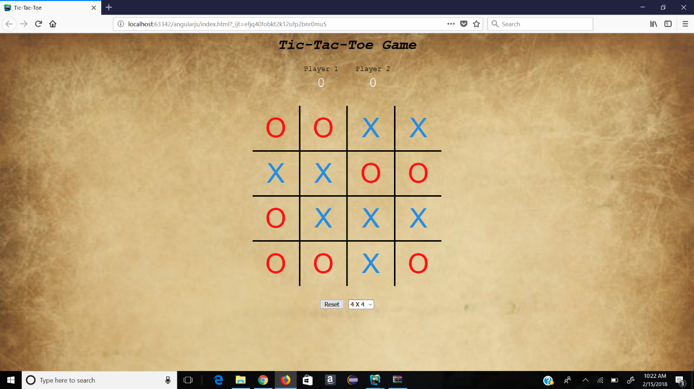

**5.**When the marks are aligned the page displays which player has won. Player 1(X) has won by marking his marks horizontally.

The following screenshot displays that X Has Won:

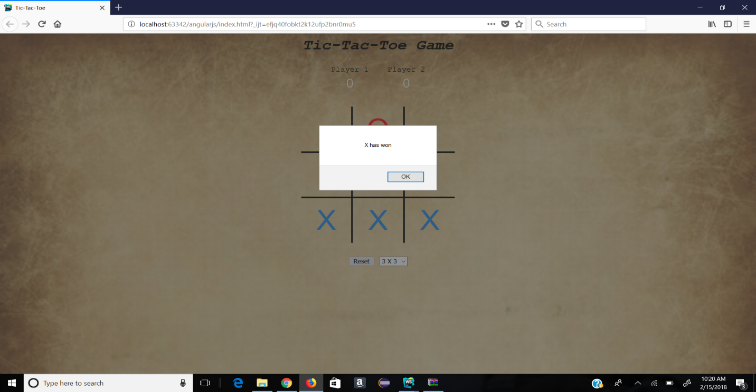

Player 2(O) has won by marking his marks horizontally.

The following screenshot displays that O Has Won:

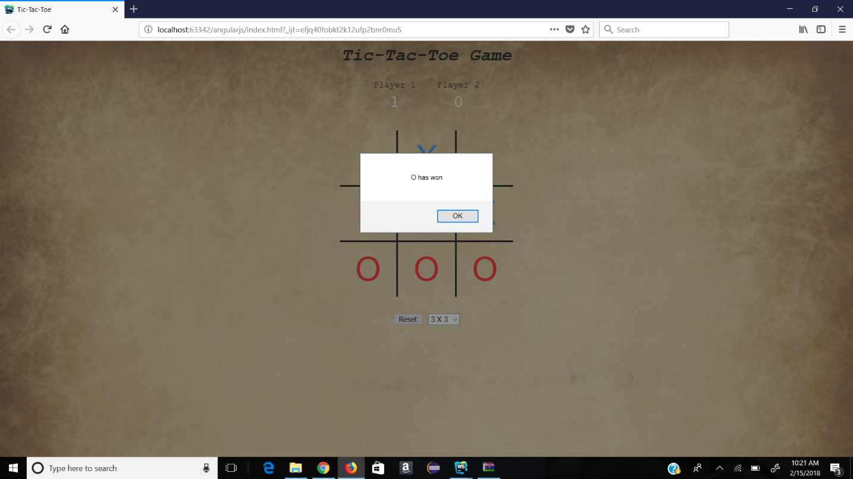

**6.**This screenshot shows the scores.

E.g: Player1: 3 and player2: 1

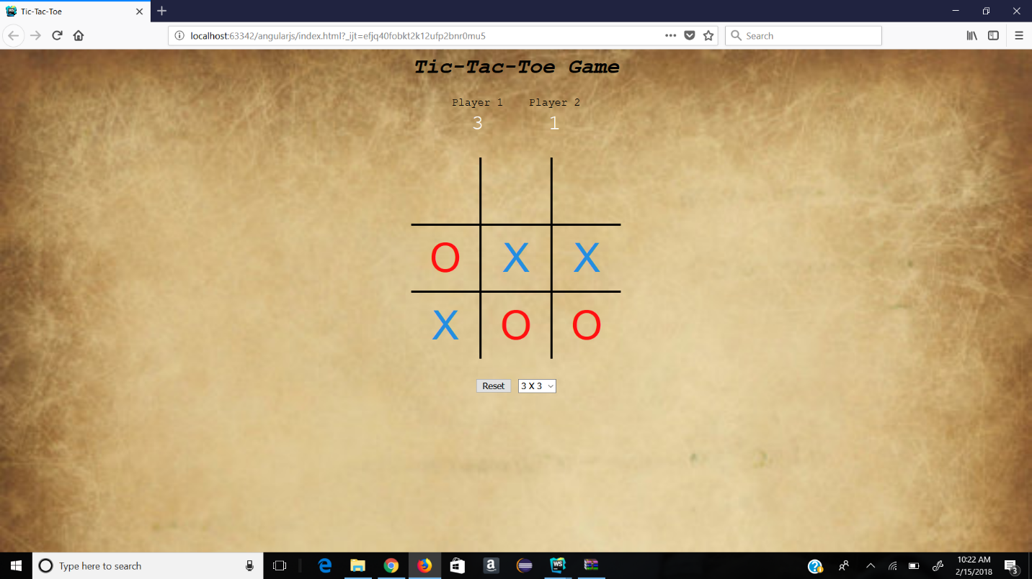

**Code snippets:**

The following are some code snippets of angular js and html:

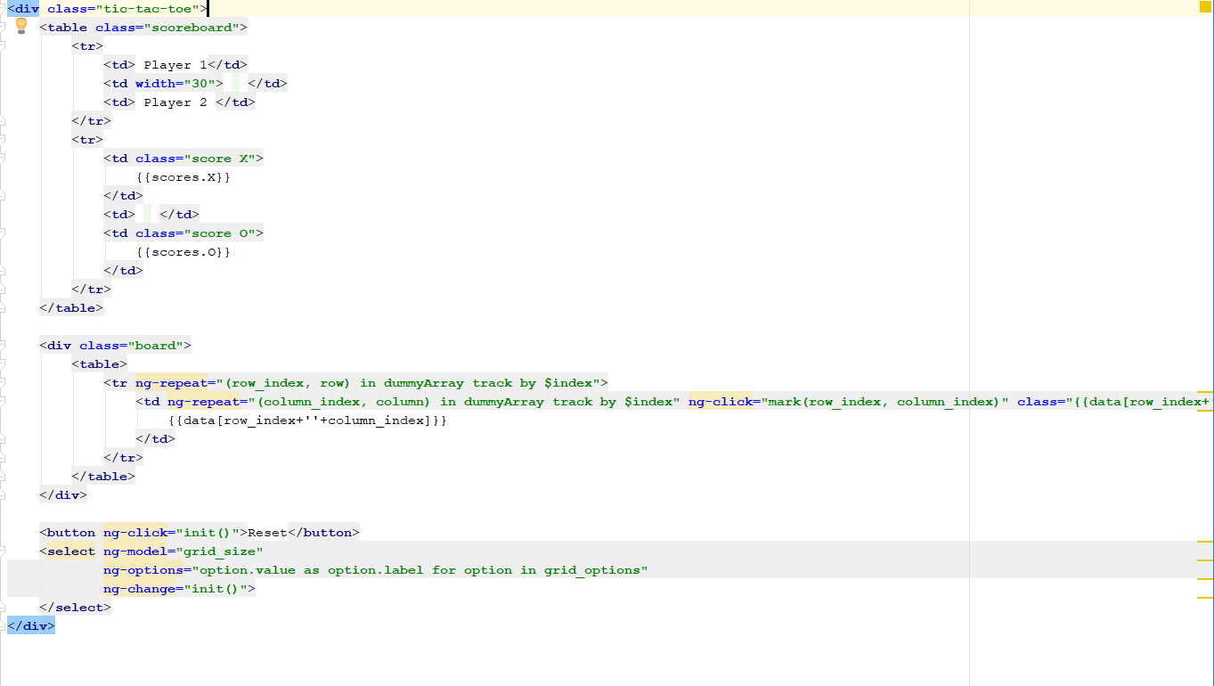

App.js:

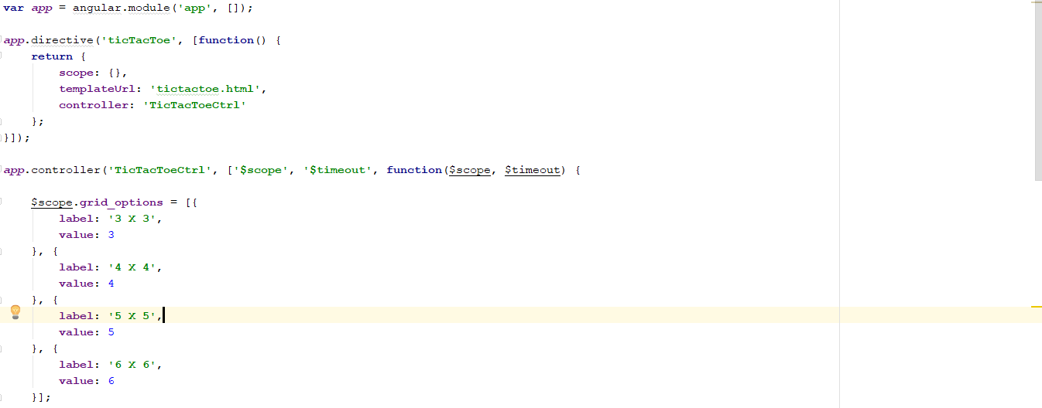

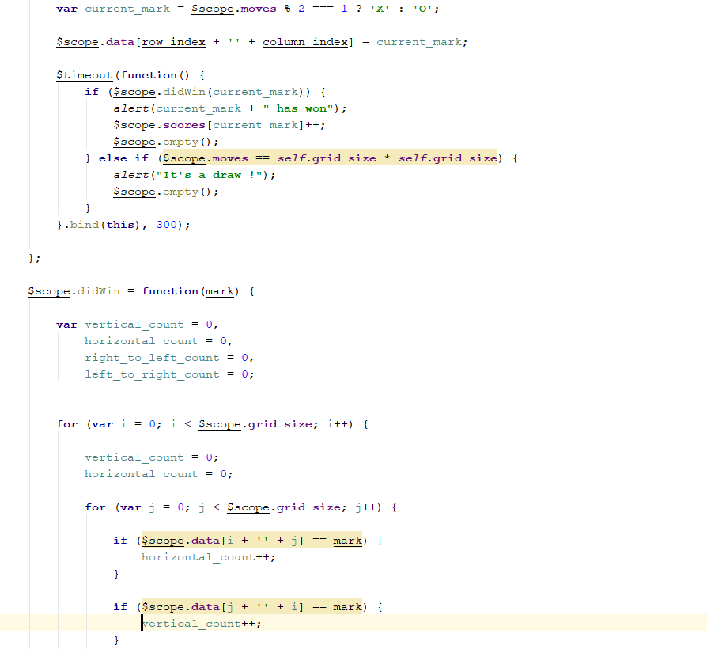

**Tools and Languages:**

* WebStorm 2017 3.3x64
* HTML5
* JAVASCRIPT
* CSS
* ANGULAR JS

**References:**

<https://www.w3schools.com/html/>

<https://newsapi.org/docs/get-started#search>

https://github.com/basilesimon/using-an-api-tutorial/blob/master/tutorial.md

<https://css-tricks.com/almanac/>

http://tutorials.codebar.io/js/lesson4/tutorial.html

**GitHub Link:**

https://github.com/Ravali2007/CS5590-490